Actors

Sales Assistant
Sales Assistant is a person who is responsible of managing customer and customer site information. If there are needs on managing customer’s information or customer site, creating, updating and marking for deletion. Sales person makes those necessary changes or marking for deletion, but all those changes need to be confirmed by authorized sales assistant.
Sales Planning
Sub-system; according to specific customer, sales’ planning is going to use information from customers for setting up discount rates and etc.
Order Processing
Sub-system which is going to use existing customers and customer sites information.

Services

Registering new customer/ customer site
Updating customer/customer site
Confirm customer/customer site update
Mark customer/customer site to be deleted
Display customer/ customer site information

Use Cases

Diagram:
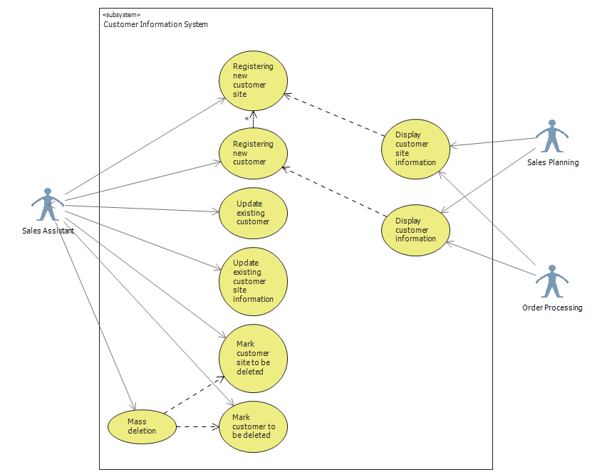
Descriptions:
Use Case | Registering new customer
Actor: | Sales assistant
Pre-condition: | Customer wants to have permanent registration in Lahjapaja system or Lahjapaja contacts potential customer;  Sales assistant logged in into the system.  Information about company’s creditability is checked by some responsible employee
Goal: | Acquiring information about the customer and preparing it for the final acceptance of relationship with him.
1 | Sales assistant press new customer button
2 | Sales Assistant inserts company name, invoicing and delivery address, contact person information (name, tel. number, email, address) and other possible info.
3 | Fill the creditability information.
4 | Based on the creditability information and turnover of the company:  - discount rate %  - credit limit
5 | Selects the customer group
6 | Selects terms of payment, terms of delivery
7 | Conract agreement (references) and status?!!?!
8 | Press Save button to store the inserted information
8 | New customer is stored in the system's database.

Use Case | Registering new customer site
Actor: | Sales assistant
Pre-condition: | Customer site will contact LahjaPaja or Lahjapaja will contact the customer;  Basic customer information is stored in the system;  sales Assistant logged in the system  Sales Assistant and Register Customer page or Display customer page is opened in front of him/her ;
Goal: | Acquiring information about new customer site for the order processing purposes
1 | Sales assistant press new customer site button On Register/ Update customer page or Display Customer page.
2 | Based on the customer ID or name of the customer the screen will show customer information/ The new customer information are being inserted into the system
3 | The customer site information is added to other customer sites/ the customer site information is inserted as the consequent process of Registering new customer use case.  The addresses, customer group, discount group credit limit, terms of payment and terms of delivery, addresses, contact person information, additional information is pre-filled based on the information valid for HQ.  The Site name, is newly inserted and Customer site ID is generated.
4 | Press Save button to store site information into the system

Use Case | Update existing customer
Actor: | Sales assistant
Pre-condition: | Customer or someone in house notifies of changes or errors in stored data  Sales Assistant Logged in the system  Display customer page is opened in front of him/her ;
Goal: | Updating of data in the system
1 | Sales Assistant selects the desired Customer by its name or ID
2 | Press Update Customer Button.
2 | Based on the customer ID or name the screen Register/Update Customer will show customer information.
3 | Alter existing customer's information if needed.
4 | Press Save Button to store altered information.

Use Case | Update existing customer site information
Actor: | Sales assistant
Pre-condition: | Customer or someone in house notifies of changes or errors in stored data  Sales assistant logged in;  Display customer page is opened in front of him/her ;
Goal: | The existing information about customer site is updated and stored in the system
1 | Sales Assistant selects the desired Customer Site by its name or ID
2 | Press Update Button
3 | System deliver all information about particular customer site and opens the Register/Update customer site
4 | Alter existing customer site information if needed.
5 | Press Save Button to store altered information.

Use Case | Mark customer site to be deleted
Actor: | Sales assistant
Pre-condition: | Particular customer site is not needed in the system anymore  Lahjapaja’s decision to delete  Sales assistant logged in;  Opened Display Customer;
Goal: | The existing information about customer site is marked to be deleted from system
1 | Sales Assistant selects the desire customer site by its name or ID
2 | Sales Assistant presses Update Customer site button
3 | The Update Customer Site page will open with prefilled data fields
4 | Sales Assistant checks Mark For Deletion checkbox
5 | The system will prompt the user again, if s/he is sure
6 | Press Save Button to apply the changes
7 | Customer site will wait for mass deletion process.

Use Case | Mark customer to be deleted
Actor: | Authorized Sales assistant
Pre-condition: | Customer is not interested anymore in business;  Lahjapaja’s decision to delete;  Sales assistant logged in;  Opened Display Customer;
Goal: | The existing information about customer is marked to be deleted from the system
1 | Sales Assistant selects needed customer by its name or ID
2 | Checks if customer has any sites more (by system)
3 | The Update Customer page will open with prefilled data fields
4 | Sales Assistant checks Mark For Deletion checkbox
5 | The system will prompt the user again, if s/he is sure to mark for the deletion.
6 | Press Save Button to apply the changes

Use Case | Mass deletion
Actor: | Sales Assistant with special permission
Pre-condition: | Certain customer or customer sites were marked for deletion by some sales assistant  Sales Assistant logged in as the actor with special permission;  Display customer page is open and list of marked customer or sites is available;
Goal: | The existing information about customer or site is deleted from the system
1 | Responsible actor filters the customers or sites by status (marked to be deleted)
2 | Press Mass Delete Button
3 | Confirmation window will appear
4 | Confirm Deletion

Use Case | Display customer information
Actor: | Sales Planning subsystem/Order processing subsystem
Pre-condition: | There is a need in utilizing customer information.  Customers’ information is stored in the system and is available to be displayed.  The actor has access to the database tables with information about customer or/and customer sites.
Goal: | The acquired information about a customer is utilized.
1 | The actor selects a customer according to the actor’s needs.
2 | The customer information is displayed on the screen: company name, invoicing and delivery address, contact person information, way of delivery and other possible information based on the UI of the subsystem.

Use Case | Display customer site information.
Actor: | Sales Planning subsystem/Order processing subsystem
Pre-condition: | There is a need in utilizing customer site information. Customer sites’ information is stored in the system and is available to be displayed.  The actor has access to the database tables with information about customer or/and customer sites.
Goal: | The acquired information about a customer site is utilized according to particular actor’s requirements.
1 | The actor selects a customer site according to corresponding subsystem architecture and the actor’s needs.
2 | The customer site information is displayed on the screen: company name, invoicing and delivery address, contact person information, way of delivery and other possible information based on the UI of the subsystem.
3 | The actor chooses the desired information and processes it according to corresponding subsystem needs.

